- Make the configuration object Products more user-friendly - it should allow user to store items in groups, but the depth of the hierarchy should not exceed 4 groups. The field of a group/parent must be called “Group” in the interface.
- Add a predefined item “Vietnam” to Countries configuration object. Make the RegistrationCountry attribute automatically filled in with the value “Vietnam” on creating a new Counterparty.
- Select a suitable metadata class for list of contracts between us and counterparties and create a configuration object CounterpartyContracts. Each contract should be subordinated to Counterparties configuration object. The field of the owner must be called “Counterparty” in the interface. The object should be name as “Contract” in the singular form.
Implement the functionality of entering additional agreements to contracts. To do this, one item can be nested within another item, in which case the parent item is a contract, and the subordinate item is an additional agreement. Additional agreement can not be a parent of another contract. The field of parent must be called “Main contract” in the interface.
A code/number of CounterpartyContracts should be unique within subordination to owner. It must also be filled in manually by a user.
- Add an attribute Contract to the SalesInvoice configuration object Contract. This attribute must allow selection among customer’s contracts only (“Customer” attribute of SalesInvoice object).
- Make a code/number of the SalesInvoice configuration object unique within a year.

Although we will get acquainted with the basics of coding later, it is better to start with simple operations now in order to fully reveal the capabilities of the 1C platform and make our solution closer to the real one. We will also touch on the topic of forms a little, which we will study in detail in one of the following lessons.

- Let's add the Amount (Number(15, Non-negative) attribute to the Products tabular section of SalesInvoice document and write code that will recalculate this amount in real time. We will recalculate the amount when the quantity or price of the goods changes.
- Create a document’s form

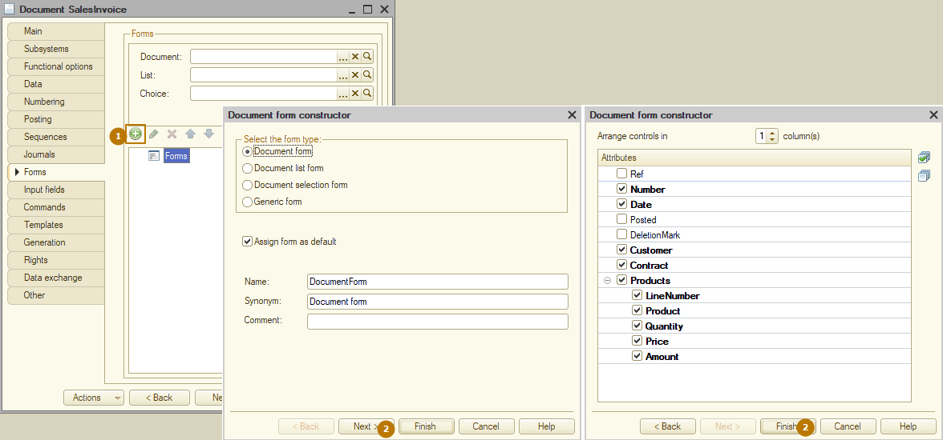
- Now disable editing for the Amount field by enabling the “read-only” property in the properties palette. The properties palette can be opened by double-clicking on an element (ProductsAmount is squared in the screenshot) or by right-clicking on it and clicking Properties.:
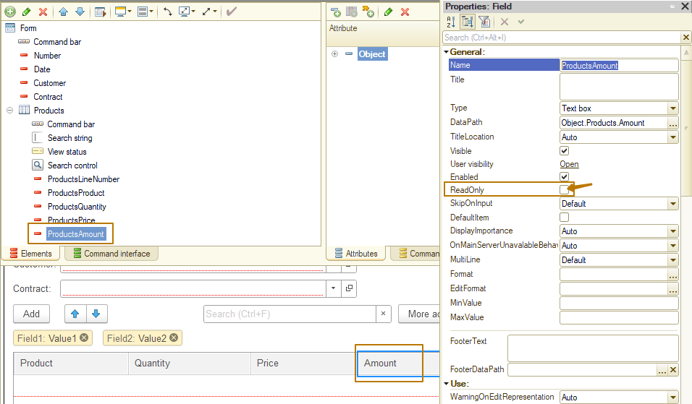
Let's create an "OnChange" event handler for Quantity and Price fields. The topic of events will be studied later, for now we will only say that the form and its elements have events that are processed in a standard way. However, the developer has the opportunity to replace the standard processing with its own algorithm.
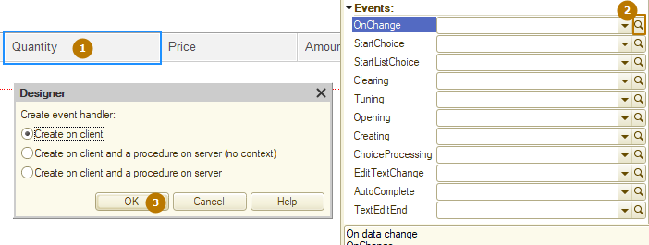
You can see that the focus has shifted to the form module, in which the code of the “On change” event handler procedure has appeared:
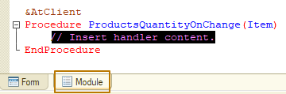
- The "On change" event is processed at the moment when the field value has already been changed, it does not have the ability to cancel the standard processing, just write code that receives the data of the current row of the table and calculates the sum value:
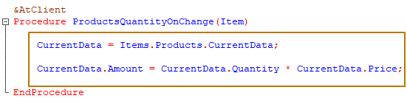
- We should repeat the same action for the Price field:
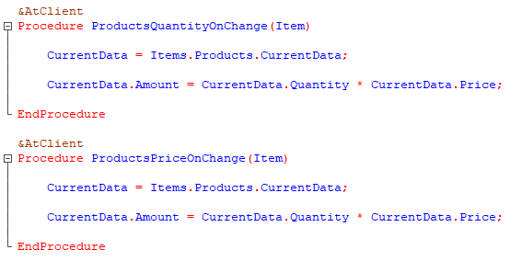
The problem is that now our program contains code duplication. You can read about what it is and why it is bad on your own, I will only say that if we need to refine the algorithm, for example, with each recalculation of the amount in the column, we will need to recalculate the sum of the entire document, then we will have to make these changes in both procedures.
- Therefore, let's create a procedure CalculateAmountAtRow, in which we will transfer the recalculation code, and we will call this procedure from event handlers:
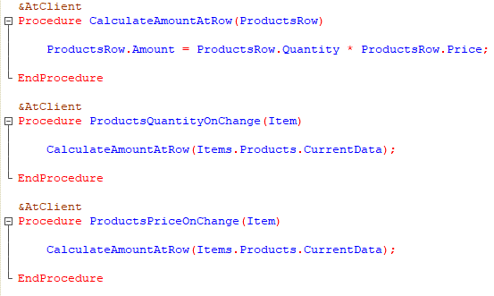
Repeat these actions by yourself.

